The 620BA
Igniter Circuit Tester &
Fail-Safe Ohmmeter
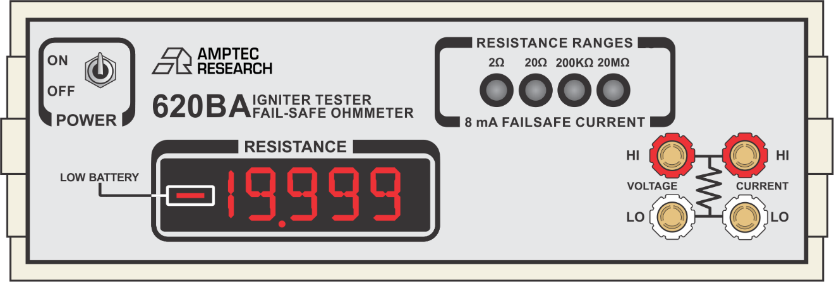
The 620BA Igniter Tester is a portable digital ohmmeter specifically designed for ultra-safe resistance testing on explosive devices. Approved by the USAF Non-nuclear Munitions Safety Board and compatible with our RS232C Interface (OP-232), this product is the safest and easiest to use in its field.

The AMPTEC 620BA offers fail-safe current limiting resistor network circuitry to ensure that instrument test currents cannot exceed 8 mA. In the unlikely event of a component failure, the output current limiting network would still be in effect. If the 620BA had an electrical fault, it offers the life-saving advantage of failing safely.

The 620BA is part of a lineage of intrinsically safe igniter circuit testers in the 620 Series product line, enabling you to take high-accuracy resistance measurements across virtually any range from 2 Ω to 20 MΩ.

Every AMPTEC product is proudly made from start to finish in the USA and comes with a one-year warranty, plus an N.I.S.T calibration certificate with data at no extra cost.

The gold standard in ultra-safe resistance testing.

AMPTEC 620BA Igniter Circuit Tester Datasheet

The below specifications apply to units that are purchased as a part of our 620BA Commercial Package with no additional options. For information on the specifications of units with additional options, please refer to the following page.

AMPTEC 620BA Range, Resolution, Accuracy, & Current Levels
Range | 2 Ω | 20 Ω | 200 KΩ | 20 MΩ
Nominal Current | 5 mA | 5 mA | 0.5 uA | 5 nA
Failsafe Current | 8 mA | 8 mA | 8 mA | 8 mA
Resolution | 100 uΩ | 1 mΩ | 10 Ω | 1 KΩ
Accuracy | ± .02% of reading & ± .05% of range | ± .02% of reading & range | ± .05% of reading & range | ± 2% of reading & ± .02% of range

AMPTEC 620BA General Specifications
Display ……….…………. 4 ½ digit LED display |  | Dimensions ……………..... 9.75” x 10” x 3.25”
Input Voltage ……………... 4.8 VDC maximum |  | Internal Voltage …….…...... 250 VDC maximum
Low Battery ….…….………. Display reads”—" |  | Open Circuit …….….…………………... 1.6 VDC
Overload/Overrange ……....… Display flashes |  | Terminal ……....…… Banana jack binding posts
Temperature Coefficient ... ± 0.002% per 1º C |  | Temperature Limit (Operating) ……. 0º to 50º C
Temperature Limit (Storage) .….. -20º to 70º C |  | Update Rate ……...……. 3 readings per second
Weight (Standard Version) ……..….….. 3.5 lbs.
AMPTEC 620BA Power Specifications
Batteries …..... 4ea 5000 mAh NICAD batteries |  | Battery Charge Time ….... ~8 hrs. til full charge
Battery Charger ……..….…... AMPTEC 620-DC |  | Battery Charger Charging Current ….... 2A max
Battery Charger Input …………... 90 – 264 VAC |  | Battery Life ……………. 1000 cycles or 3 years
Battery Charger Output …….…….…….… 5.9V
OP-232 RS232C Interface Specifications
This option enables your unit to connect to a computer and receive commands via RS232C. OP-232 comes standard with the purchase of a 620BA Igniter Tester.
Connection ………..…....…..... DE-9 connector |  | Rear terminal block …. 4 Gold-Plated terminals
AMPTEC 620BA Igniter Circuit Tester Datasheet Continued

OP-247 Optically Isolated Power Specifications
This option enables your unit to be ran via AC power, allowing for uninterrupted use. Unless otherwise noted in the table below, all other specifications match those listed in the general specifications section.
AC/DC adaptor …..….…...… AMPTEC 247-DC |  | Adaptor input ……..….…..……..……. 120VAC
Adaptor output ……..……...…..……… 24 VDC |  | Unit Weight ……………..…..………..… 2.3 lbs
Op-519 Rack Mount Specifications
This option, OP-519S (for single units) and OP-519D (for dual units), allows your unit to be rack mounted. Unless otherwise noted in the table below, all other specifications match those listed in the general specifications section.
OP-519S (Single Unit) |  | OP-519D (Dual Units)
Dimensions …………..….. 19” x 3.5” x 10” |  | Dimensions ……………….. 19” x 3.5” x 10”
Materials ….…. ABS plastic face, aluminum |  | Materials ……... ABS plastic face, aluminum
Weight …….….…. 2.3 lbs (plus unit weight) |  | Weight ……….…. 2.1 lbs (plus unit weights)
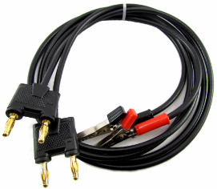
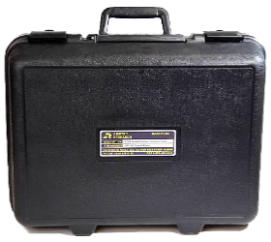
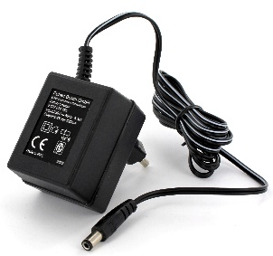

AMPTEC 620BA Ordering Information
620BA | Igniter tester, OP-300 leads, 620-DC battery charger, N.I.S.T. calibration certificate
OP-100 | Meter transit/hard shell case
OP-110 | Test lead storage pouch
OP-232 | RS232C computer Interface
OP-247 | Optically isolated power
OP-290 | Alligator clip test lead set
OP-300 | Gold plated 4-Wire Kelvin clip leads
OP-302 | 5-way banana jack backed Kelvin clips
OP-401 | Gold plated single tip Kelvin probes
OP-519S | Single rack mount tray
OP-519D | Dual rack mount tray
The above is only a small selection of the accessories that are compatible with the 620BA meter. For a full list or pricing information, please contact us via our website: www.amptec.com

